Concentrated Animal Feeding Operations of the Pacific North West
By. Evan Barbarick
This report analysis CAFO’s of the Pacific northwest and there relation to major waterways as well as their total fertilizer and carbon dioxide output. The report also briefly examines CAFO’s and there relation to major eutrophic zones of the Washington coast. All analysis was done using the computer program ArcMap by Esri. Data that was not available was manually added via digitization and the eutrophication zones contain a high degree of uncertainty. Final analysis shows that the largest CAFO’s are located along either the snake or Columbia River, with the larges being in Northwest Idaho.

Introduction

The purpose of his report is to analysis the major CAFO’s (Concentrated Animal Feeding Operations) of the Pacific Northwest in relation to major waterways and costal zones. CAFO’s have been shown to be a form of point source solution for water pollutants such as nitrogen and phosphorus and are responsible for up to 1.6 tons of manure produced annually in the United States, approximately 20 times the amount produced by humans (Hribar 2010). These pollutants can enter major water ways, contaminating water supply, and can also find their way in to major bays, contributing to the process of eutrophication.
Eutrophication is the process of creating a dead zone in fresh and salt water bodies by first over nitrifying an area, followed by a bloom of algae organisms, which then leads to mass algae die off and subsequent bacterial decomposition which uses up the available oxygen. When the eutrophication process is complete the area becomes hypoxic and is a dead zone that is incapable of supporting most species.
This report also uses a simple equation to analyses the large amounts of GHG’s (Green House Gas) emitted by CAFO’s. CAFO’s are responsible for 7 percent of the total U.S. GHG emissions (Hribar 2010). This most notably in the form of large amounts of CH4 (methane) released on site, however a large portion of these emissions are hidden in transportation of feed and livestock, deforestation of rainforests to grow cattle feed, and fertilizer production which is a highly carbon intensive process. Children living near CAFO’s have been shown to have an increased likelihood of developing respiratory disease (Hibrar 2010)

Methods
All of the analysis for this report was done using the geospatial analysis, or GIS, software ArcMap by Esri, Inc. This is an incredibly useful tool as it allows for observation of large amounts of data over large spaces in a relatively short amount of time. All of the data used for this report was acquired from the USGS (United States Geologic Survey) website. Data that was not available online, such as the eutrophic zones as well as the Snake and Columbia rivers, were added to the analysis through the process of digitization which is a method of manually adding features to a map. The original data package for North American CAFO’s was highly extensive and included operations as small as 300 heads of livestock and as large as 150,000 heads of livestock. The data set has since been cut down to a base map of operations greater than 1000 heads. This filter has since been narrowed to show the top 5 largest CAFO’s, CAFO’s at 15,000 heads or more, and the largest CAFO at 150,000 heads. The same process was utilized for the waterways data set so that only the largest waterways are show. Both the Snake River and Columbian river were added to the map through digitization as the original waterways data lacked easily accessible information on large rivers.
The CAFO data set includes the total nitrogen and phosphorus generated by each operation but did not include information on total GHG emissions. To obtain this data, new field was manually added to the attribute table of the CAFO data set and was filled using the following equation:
Amount of CO2= (Total Population) (22lb of CO2 per head).
22lb of CO2 per head of cattle is based on the national average of CO2 per head of CAFO cattle. (Alex and Dennis Avery)

Results

Analysis shows that the five largest CAFO’s of the Pacific Northwest are located along either the snake or Columbia River in either Washington of Idaho. The largest CAFO is located in Idaho, has a population of 150,000 and is located within a mile of the Snake River. Very little data was available for eutrophication and so this information contains a lot of uncertainty in regards to the maps below however it does outline the general area in which eutrophication and hypoxia would be expected.

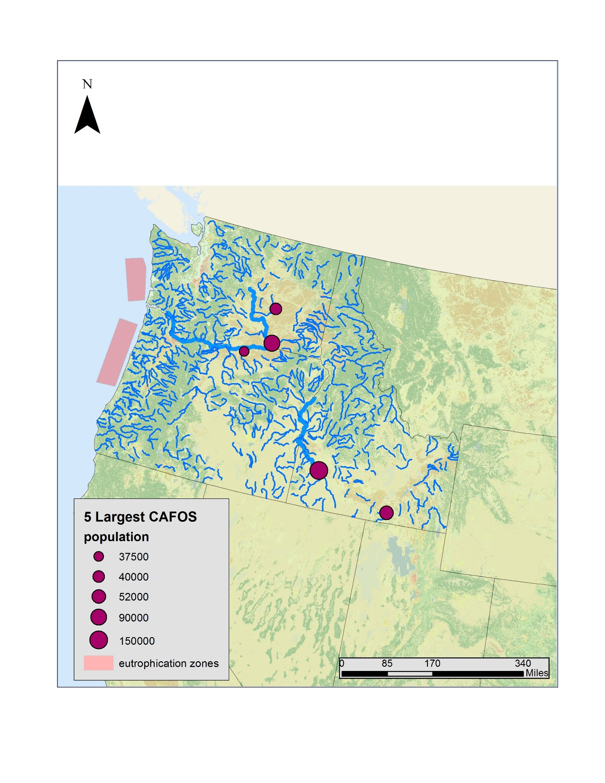
Figure 1: 5 largest CAFO’s
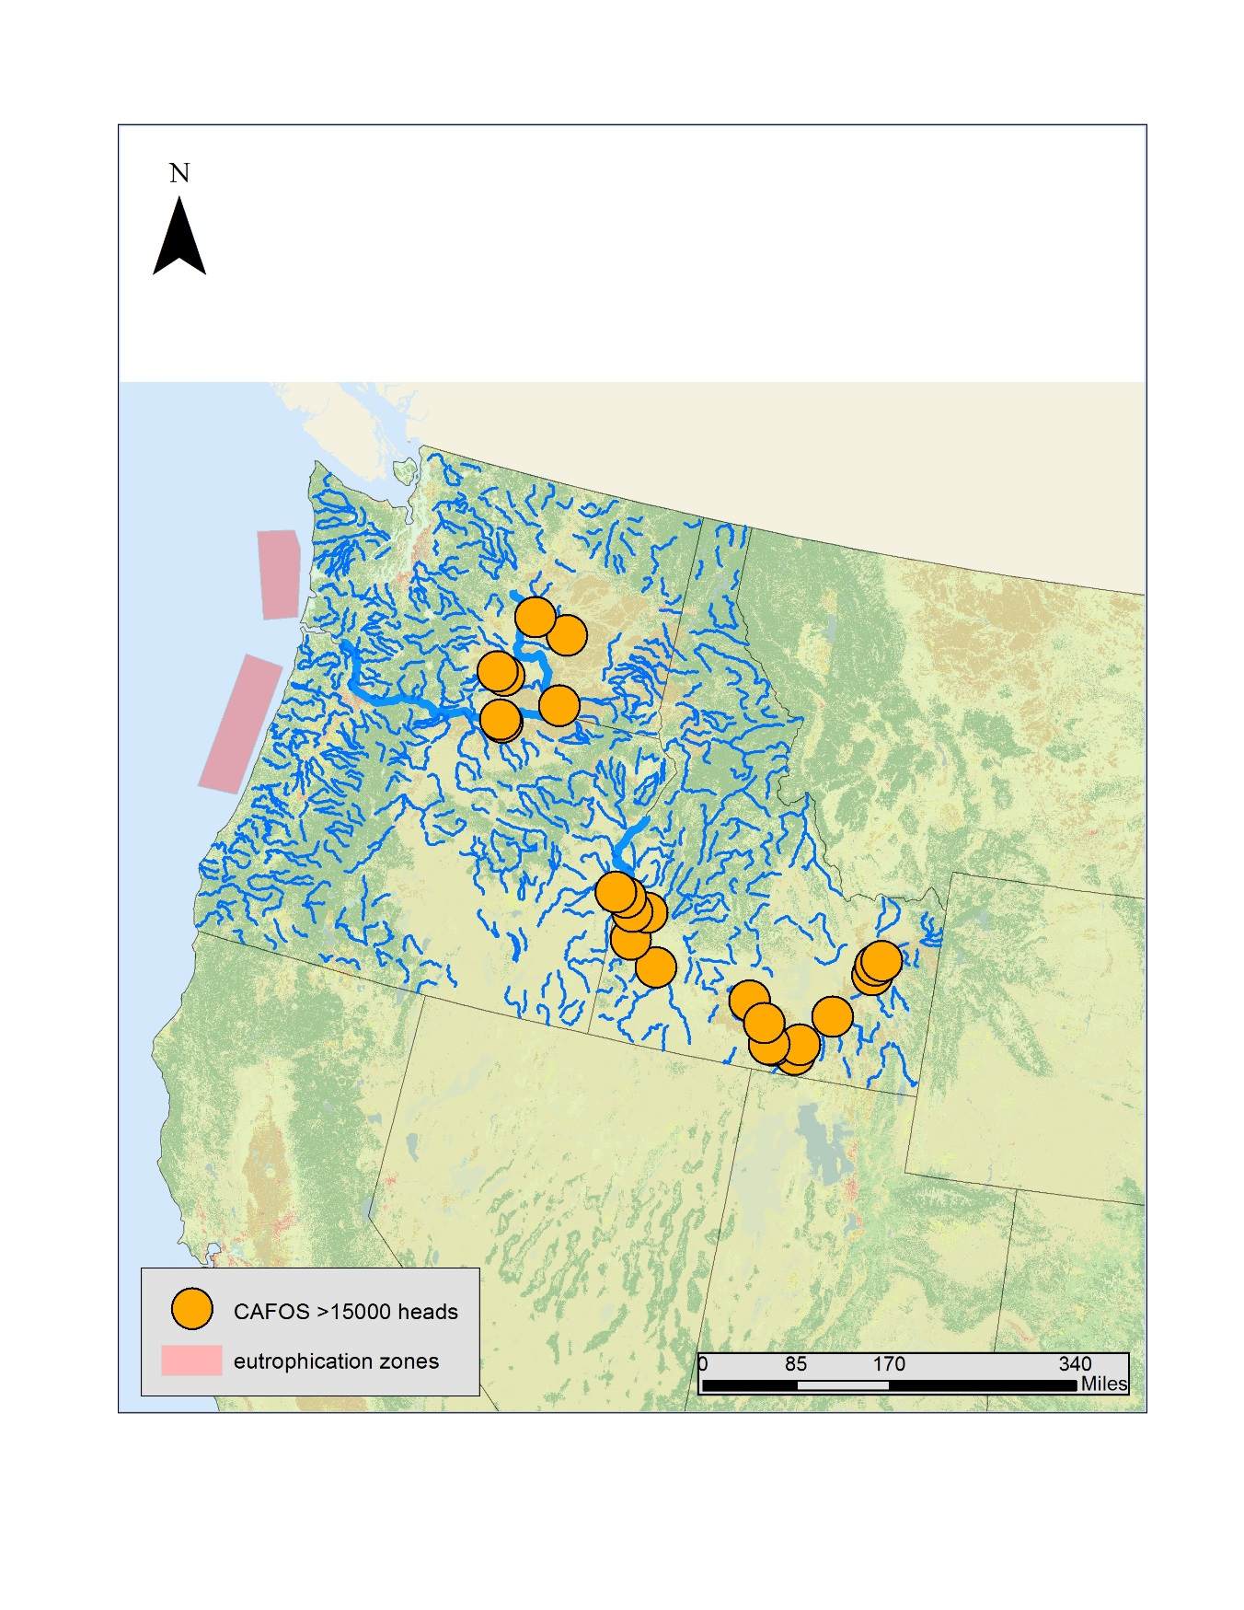Figure 2: CAFO’s with more than 15,000 heads of livestock
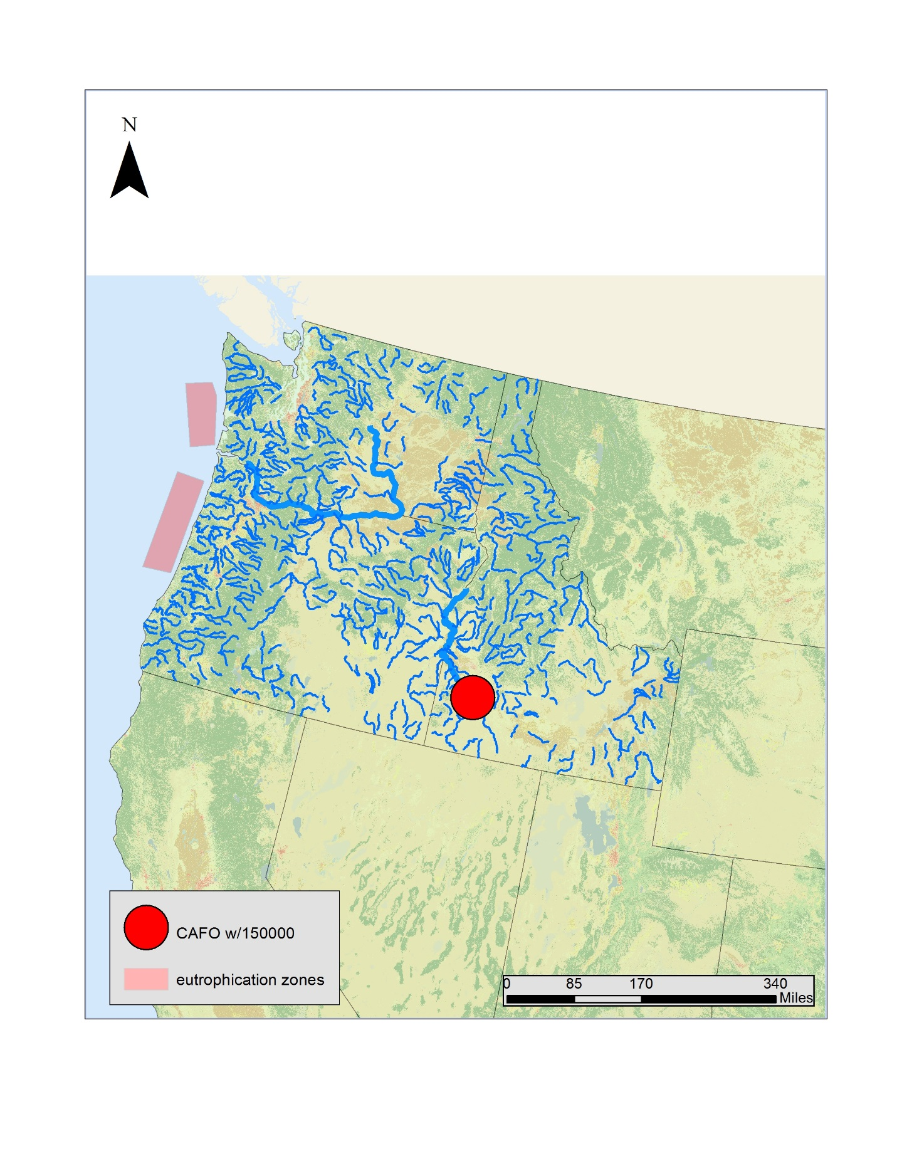
Figure 3: The largest recorded CAFO in the Pacific North West
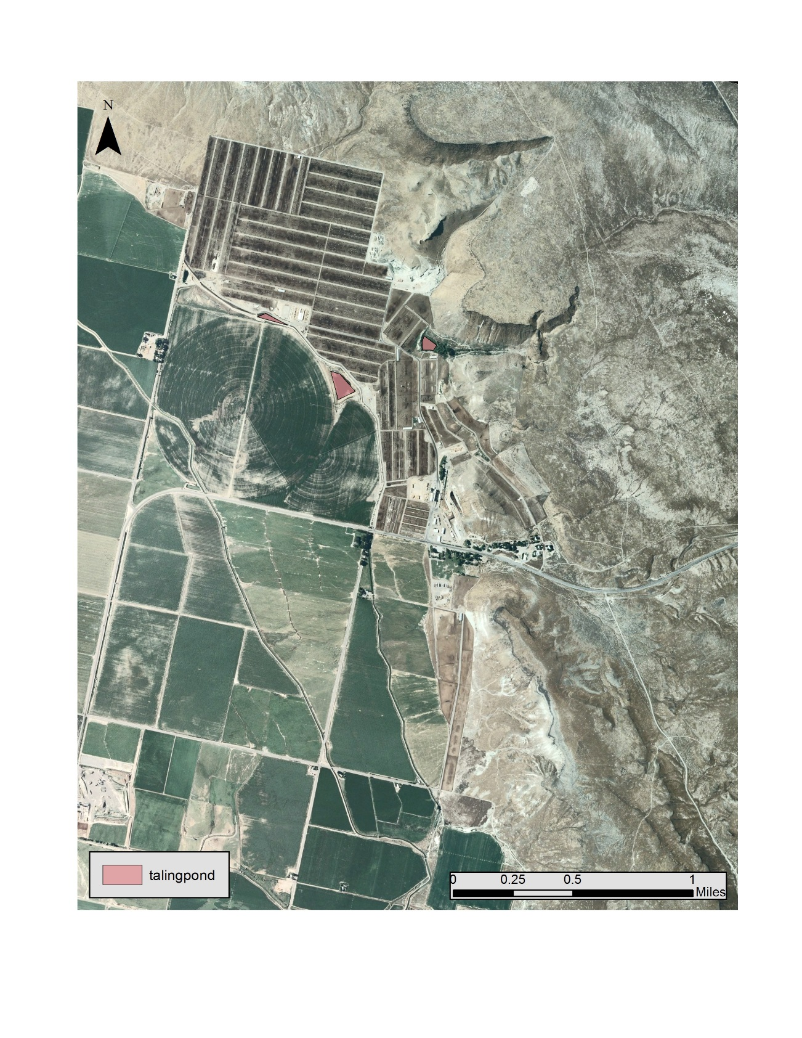
Figure 4: A close up of the largest CAFO in Idaho

Population of livestock | Nitrogen runoff (g/year) | Phosphorus runoff (g/year) | GHG emissions (kg/year)
150,000 | 10226451 | 3614280 | 3300000
90000 | 2771854 | 979642 | 1980000
52000 | 2166365 | 765647 | 1144000
40000 | 2082934 | 736160 | 880000
37500 | 1851249 | 654277 | 825000
Table 1: The 5 largest CAFO’s of the northwest and their associated runoff.

Conclusion
Analysis shows that the there is a large number of CAFOS located within the pacific northwest of the United States all of which are located close to major water ways of the region. The largest CAFO’s, operations over 15,000 are located within Washington and Idaho with the largest operation (150,000 heads) bordering the Snake River in Idaho. The positon of the large CAFO’s along the Columbian river suggests that they contribute to the eutrophication which is occurring just off the coast of Washington, however there are more factors that can contribute to this phenomenon and a more in depth study would be required to analyze these factors in relation to fertilizer runoff from CAFO’s

Acknowledgments:

Basemap: Originator: U.S. Department of Commerce, U.S. Census Bureau, Geography Division/Cartographic Products Branch Publication Date: 201505
Land Cover: Earth Explorer
CAFO’s and Waterways: United States Geologic Survey
Orthographic Imagery: university of Idaho
Avery, A., & Avery, D. (n.d.). Beef Production and Greenhouse Gas Emissions. Retrieved May 06, 2016, from http://www.ncbi.nlm.nih.gov/pmc/articles/PMC2535638/

